DECK CARDS GAME WITH ORACLE APEX
The document illustrates the prototype of a Deck, cards and the ability to shuffle them.
- Solution
The idea is that to create a deck and cards and have the provision to shuffle them, we first need to create that information and store it. In this prototype, we will be storing the data in a DB table. Then, there will be a PL/SQL package which contains the logic to shuffle the cards stored in the table. This package will be triggered when an event is fired from the UI, and the resulted shuffled cards data will be updated in the table and thereby will be displayed back to the user.

- Development Environment Setup (Oracle APEX)
To setup a development environment is APEX, there are three layers that we will be typically needing:
- Oracle Database
- APEX workspace:
  - A workspace to build, manage and deploy application within a single oracle database instance.
  - DB schema
- Development tools:
  - APEX app builder – for developing UI
  - SQL Developer – for performing database operations like table creation, packages and all other DB objects. We can also use SQL workshop in APEX app builder for this purpose but would prefer SQL developer
  - Git for version control

- DB Structure
We are going to model the domain as:
- Table: DECK_CARDS
This table contains all 52 cards with each row representing one card only
CREATE TABLE DECK_CARDS (
CARD_ID NUMBER PRIMARY KEY,
SUIT VARCHAR2(10) NOT NULL,
RANK VARCHAR2(5) NOT NULL,
POSITION NUMBER NOT NULL,
CREATED_ON DATE DEFAULT SYSDATE,
UPDATED_ON DATE DEFAULT SYSDATE
);
SUIT: 'Hearts', 'Diamonds', 'Clubs', 'Spades'
RANK: 'A','2','3','4','5','6','7','8','9','10','J','Q','K'
POSITION: current order in the deck (this is what shuffling changes)
CREATED_ON: when this deck card row is created
UPDATED_ON: when this deck card row is updated
- Create the data to populate all the 52 cards in the table DECK_CARDS. This gives a complete deck stored permanently in the database. The below script needs to be run once after table is created. The POSITION column represents the position/order of the card in the deck. Initially it is set to ZERO.

BEGIN
FOR s IN (SELECT 'Hearts' suit FROM dual UNION ALL
SELECT 'Diamonds' FROM dual UNION ALL
SELECT 'Clubs' FROM dual UNION ALL
SELECT 'Spades' FROM dual)
LOOP
FOR r IN (SELECT 'A' rank FROM dual UNION ALL
SELECT '2' FROM dual UNION ALL
SELECT '3' FROM dual UNION ALL
SELECT '4' FROM dual UNION ALL
SELECT '5' FROM dual UNION ALL
SELECT '6' FROM dual UNION ALL
SELECT '7' FROM dual UNION ALL
SELECT '8' FROM dual UNION ALL
SELECT '9' FROM dual UNION ALL
SELECT '10' FROM dual UNION ALL
SELECT 'J' FROM dual UNION ALL
SELECT 'Q' FROM dual UNION ALL
SELECT 'K' FROM dual)
LOOP
INSERT INTO DECK_CARDS (suit, rank, position)
VALUES (s.suit, r.rank, 0);
END LOOP;
END LOOP;
COMMIT;
END;
/

- Shuffle logic. This below logic will update the POSITION column using a random ordering.
CREATE OR REPLACE PROCEDURE SHUFFLE_DECK_CARDS AS
BEGIN
MERGE INTO DECK_CARDS c
USING (
SELECT card_id,
ROW_NUMBER() OVER (ORDER BY DBMS_RANDOM.VALUE) AS new_position
FROM DECK_CARDS
) r
ON (c.card_id = r.card_id)
WHEN MATCHED THEN UPDATE SET c.position = r.new_position
, c.updated_on = sysdate;
COMMIT;
END;
/

- Application Structure – UI
- Page: “Deck viewer” to be created in Oracle APEX Workspace
- Region 1: An interactive report needs to be created in this page which will show the deck in its current order. The underlying source of this report will be the SQL query pulling the information from DECK_CARDS table.
- Button: “Shuffle the Deck”: A button on the page which shuffles the deck.
- A dynamic action with a click Event needs to be created which will fire an Action to execute PL/SQL code to run procedure
BEGIN
SHUFFLE_DECK_CARDS;
END;
- A second dynamic action is created that refreshes the Deck report region with the shuffled card positions.

RESULT: When the user clicks Shuffle the Deck, the table updated and the report refreshed, showing a new random order.
- Delivery Pipeline
- Version Control (Git)
Store APEX export fAPP_ID.sql file
Database scripts – tables, PL/SQL
- Build: Validate SQL scripts, compile PL/SQL code to ensure there is no compilation errors
- Deploy:
Scripts to execute in SQL developer
@@apex/create_table.sql
@@apex/SHUFFLE_DECK_CARDS.sql
@@apex/fAPP_ID.sql

Few screenshots from a very basic view:
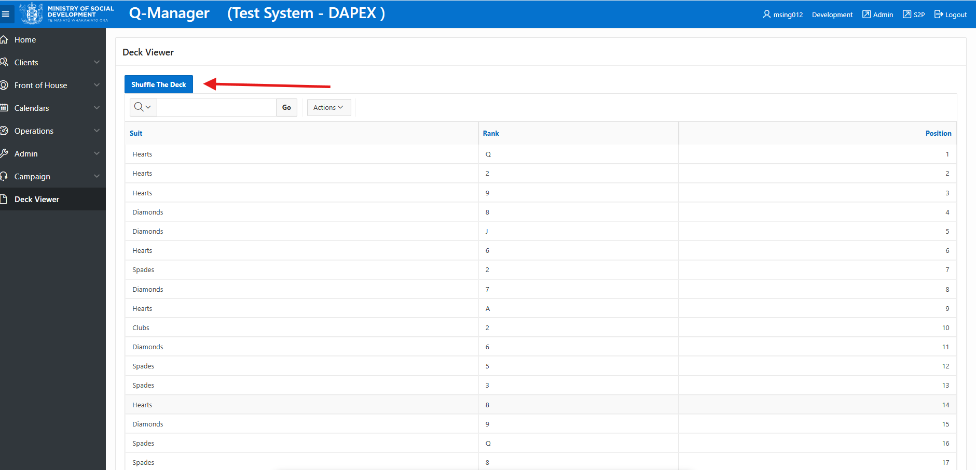
After shuffled, new order is displayed
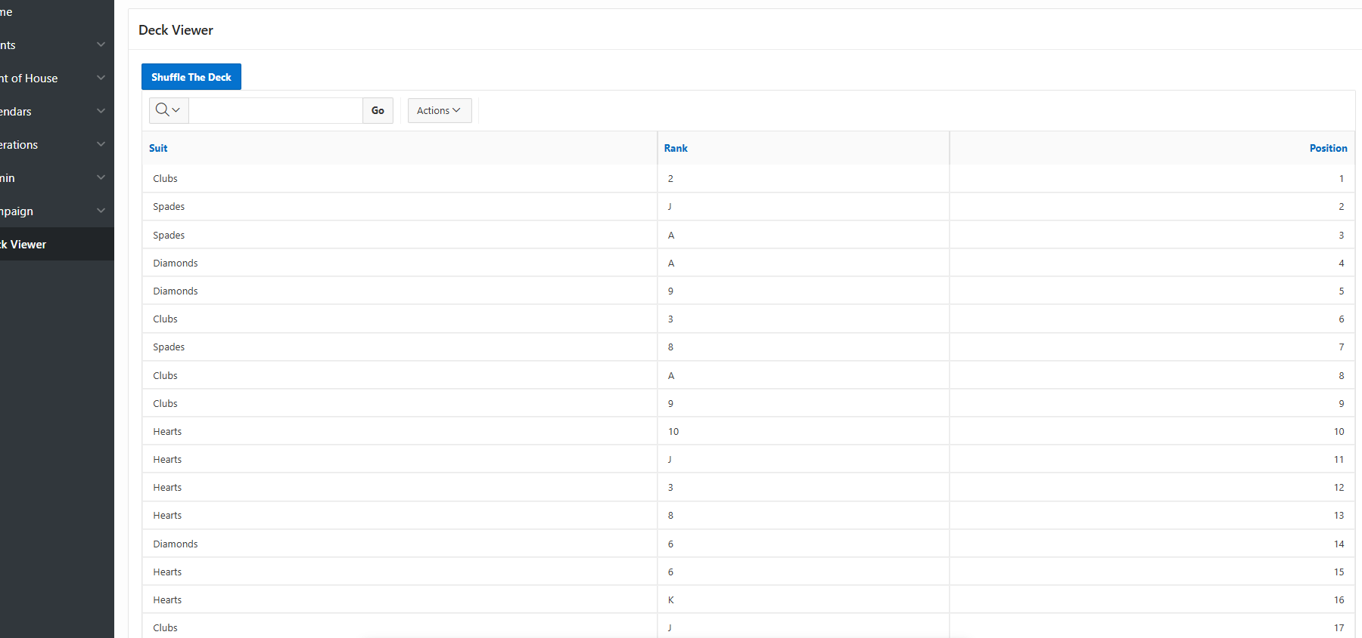

The next remaining thing to be done is to modify UI to display cards in the grid form and show the images that defines a deck of cards instead of the ones as shown as list of cards above.
For that, we need 52 images of deck of cards and store them in applications static resources section. Thereby update our source code to pull those images from the storage and tweak how the cards will be shown as grid on the APEX application page

